CSA0734-COMPUTER NETWORKS FOR SERVER MANAGEMENT

NAME: SAKTHIVEL V

REG. NO.: 192211689

EXPERIMENT 11

Implementation of Bit Stuffing using C program

Aim:

To implement Bit stuffing using C Program

Tools Required:

1.C program compiler & editor.

Procedure:

STEP 1: Bit stuffing is implemented by taking input byte array, its length, an output byte array and a pointer to the output length variable.

**STEP** 2: The main logic of Bit stuffing is using bitwise operation. If five consecutive 1s are found, a 0 bit is stuffed into the output frame.

**STEP** 3: The main function, an example input frame is provided and the bit stuffing is performed by calling the “Bit stuffing” function.

**STEP** 4: The input and output frames are then printed for verification.

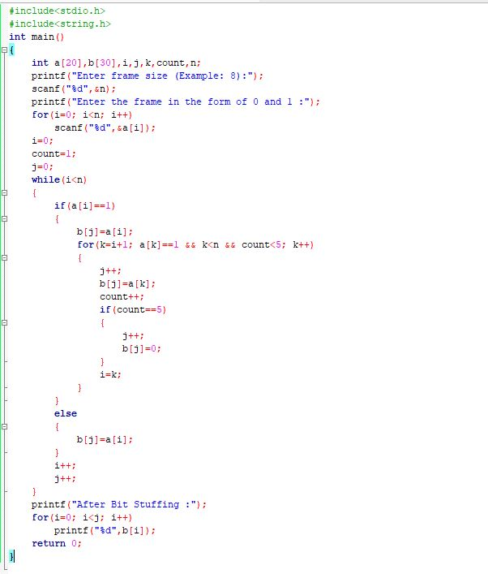

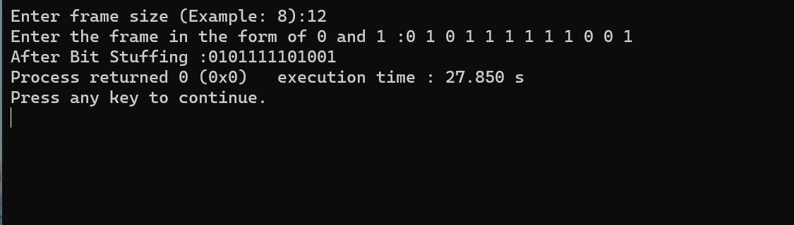

Result:

Bit stuffing mechanism using C program has been done successfully.